Software Engineering Sr. No. 26
CSC-291 Sr. No. 32
Assignment No. 04



Assignment Topic: Project Report on Event Management System

Submitted To
Dr. Mahmood Qureshi

Submitted By
Zain Tahir Sr. No. 32 FA23-BCE-111
Shehryar Arif Sr. No. 26 FA23-BCE-102

Date Of Submission: 23/12/2024
Assignment No. 04
Project Report
1. Introduction
- Overview:
The Event Management System is a feature-rich Flutter-based application designed to simplify event organization and ticketing. It caters to two primary user roles: administrators, who manage events, and users, who browse and purchase tickets. The app integrates advanced features such as Google and Firebase authentication, a chatbot named Gemini, and dark mode for an enhanced user experience.
- Objectives:
  - Provide an efficient platform for event creation and ticket management.
  - Enable users to browse events and securely purchase tickets.
  - Leverage modern tools like Firebase and Flutter to ensure performance, scalability, and cross-platform compatibility.
  - Enhance user satisfaction through features like a chatbot and dynamic theming.
- Scope:
The project encompasses key functionalities such as user authentication, event browsing, ticketing, and chatbot interaction. Additionally, it focuses on optimizing user experience through accessibility features like dark mode and real-time data updates.
- Relevance:
This project emphasizes software engineering principles by incorporating iterative development, risk management, and process improvement techniques. The use of Agile methodology ensures continuous delivery of a high-quality product.

2. App Structure
The app's modular structure ensures maintainability, scalability, and separation of concerns. The directory structure is as follows:
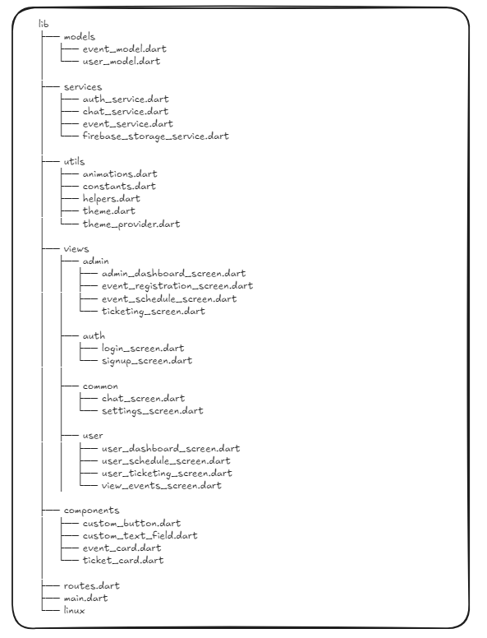
2.1 Dashboard & Feature Flow
Here’s the flowchart illustrating how the Admin and User dashboards link to their respective features, as well as the common pages (e.g., the Chat Bot):
- Admin Dashboard connects to:
  - Event Registration
  - Event Schedule
  - Ticketing (Admin)
  - Settings (Admin)
  - Chat Bot (Common)
- User Dashboard connects to:
  - Available Events
  - Scheduled Events
  - Ticketing (User)
  - Settings (User)
  - Chat Bot (Common)
- Chat Bot (Common) allows interactions that link back to both dashboards.
All the admin pages and user pages are linked and their connections along with the workflow will be something like this:
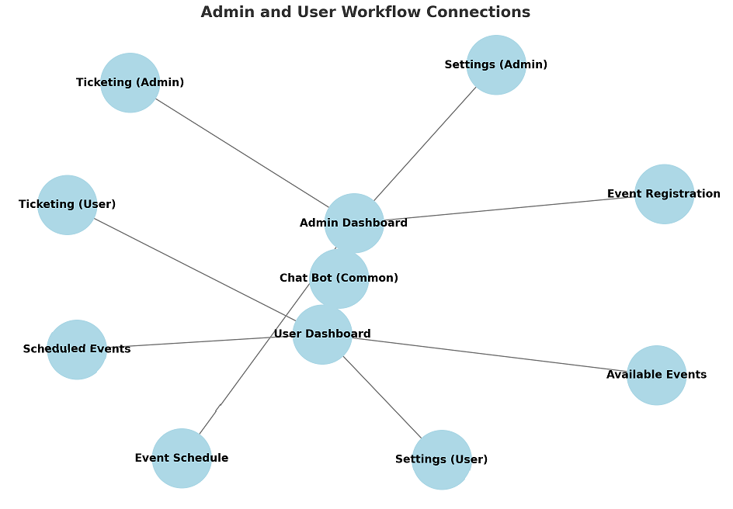
3. Literature Review
- Agile Methodology:
  - Encourages iterative development, regular feedback, and adaptability to changes.
  - Provides flexibility in accommodating new features like the chatbot during development.
- Flutter Framework:
  - Simplifies cross-platform development with a single codebase.
  - Reusable widgets and state management ensure scalable and maintainable code.
- Firebase Services:
  - Real-time database and authentication features streamline backend management.
  - Firebase Storage supports secure and efficient file management for event-related data.
- Process Improvement Techniques:
  - Plan-Do-Check-Act (PDCA) cycle for continuous refinement.
  - Incorporation of stakeholder feedback to enhance usability and functionality.

4. Project Management Methodology
- Agile Approach:
  - Divided the project into sprints, each focusing on specific features like event registration, chatbot integration, or UI enhancements.
  - Regular reviews and retrospectives to identify bottlenecks and improve efficiency.
- Tools and Techniques:
  - Microsoft To Do for task and sprint management.
  - GitHub for version control and collaboration.
  - Firebase Console for real-time data tracking.
- Risk Management:
  - Mitigated Firebase setup complexities through early prototyping.
  - Regular testing to ensure compatibility across light and dark modes.

5. System Design and Development Process
The system design and development process of the Event Management System focuses on creating a well-structured and maintainable application that effectively addresses the needs of both administrators and users. The app's architecture is built on a layered approach, with clearly defined separation of concerns, ensuring smooth scalability, easy maintenance, and flexibility for future updates.
Architecture:
The architecture of the Event Management System follows a layered design with clear separation between different concerns. This separation ensures that each component has a specific responsibility, making the codebase more organized and maintainable. The architecture is divided into the following layers:
- Models:
  - The Models layer contains the core data structures of the app, representing the entities that the system works with, such as EventModel and UserModel.
  - EventModel manages event details such as name, date, location, and ticket availability, while UserModel handles user-specific data such as authentication status, preferences, and purchase history.
  - These models are crucial for the consistency of data throughout the app, ensuring that all services and views receive accurate, up-to-date information.
- Services:
  - The Services layer is responsible for handling the core functionality of the app. This layer includes services like:
    - AuthService for handling user authentication (sign-in/sign-up via Firebase, Google authentication).
    - EventService for managing event-related tasks such as event registration, updates, and deletions.
    - ChatService for managing communication between users and the chatbot (Gemini).
    - FirebaseStorageService for handling file uploads and storage, such as images or event documents.
  - Each service interacts with the backend (Firebase) and performs specific business logic to support the app's features. These services are designed to be reusable and maintainable, ensuring that changes in business logic do not affect the views or UI.
- Views:
  - The Views layer is responsible for presenting the user interface and interacting with users. It is divided into different screens based on user roles and app functionality:
    - Admin Views: These screens allow administrators to manage the system's events, schedules, tickets, and settings. Examples include AdminDashboardScreen, EventRegistrationScreen, and TicketingScreen.
    - User Views: These screens provide users with access to available events, their scheduled events, and ticketing options. Examples include UserDashboardScreen, ViewEventsScreen, and UserTicketingScreen.
    - Common Views: Shared components like ChatScreen (for interacting with the Gemini chatbot) and SettingsScreen (for managing app preferences such as dark mode) are included in this layer.
  - The Views layer makes use of reusable components, such as EventCard and CustomButton, which help ensure consistency across the app and reduce duplication of code.
Development Process:
The development process is based on Agile principles, focusing on modularity, iterative improvements, and real-time feedback. The app is built with maintainability and scalability in mind, following best practices in software development. Key aspects of the development process include:
- Modular Design:
  - The app's design follows a modular approach where individual features are developed as independent components or modules. This allows developers to work on different aspects of the app (e.g., event registration, chat functionality) simultaneously without causing conflicts.
  - The modularity of the design is evident in the clear separation of the Models, Services, and Views layers, ensuring that each part of the application is responsible for a specific function.
  - Reusable components like CustomButton, EventCard, and TicketCard reduce code duplication, enhance UI consistency, and streamline future updates or additions to the app.
- Iterative Refinement:
  - The app is developed in iterations, where new features are built, tested, and refined based on user feedback and testing results. For example, feedback from test users on the user interface and chatbot interactions leads to regular UI tweaks to improve accessibility and usability.
  - The iterative process ensures that any issues are identified early and resolved before they become significant problems. As features like event scheduling or ticketing evolve, the app adapts to meet user needs and expectations.
- User Feedback Integration:
  - Throughout the development cycle, user feedback is continuously integrated into the app. This ensures that features such as the admin dashboard, user dashboard, and chatbot interactions align with user expectations.
  - Tools like Firebase Analytics and Flutter DevTools are used to gather feedback and monitor app performance, allowing the team to prioritize improvements based on actual usage patterns.
- Testing and Quality Assurance:
  - The app undergoes a rigorous testing process to ensure all features function as expected. Testing strategies include:
    - Unit Testing: Ensures that individual components (e.g., login, event registration) perform correctly in isolation.
    - Integration Testing: Confirms that different parts of the app, such as authentication and event ticketing, work together seamlessly.
    - UI Testing: Verifies the user interface's responsiveness, functionality, and accessibility across various devices and screen sizes.
  - Testing ensures that the app functions flawlessly in both light and dark modes, providing a consistent user experience.

6. Testing and Quality Assurance
- Testing Strategies:
  - Unit Testing: Validated individual functions like login and event registration.
  - Integration Testing: Ensured smooth interactions between the authentication module and the ticketing system.
  - UI Testing: Verified the responsiveness and functionality of dark mode and chatbot interactions.
- Tools:
  - Flutter DevTools for debugging and performance analysis.
  - Firebase Test Lab for automated testing.

7. Results and Analysis
- Project Outcomes:
  - Successfully implemented all planned features, including a dynamic chatbot and responsive UI.
  - Achieved seamless integration with Firebase services.
- Effectiveness of Practices:
  - Agile methodology enabled regular feedback integration, leading to a user-friendly app.
  - Testing strategies minimized defects and enhanced overall quality.
- Improvements Achieved:
  - Optimized API calls reduced response times.
  - Enhanced dark mode readability across devices.

8. Lessons Learned
Throughout the development of the Event Management System, the team encountered several challenges, but these were resolved through collaboration, continuous testing, and adapting to best practices. This section outlines the key challenges faced, how they were resolved, and the valuable lessons learned from the experience.
Challenges:
- Initial Difficulties with Firebase Configuration:
  - The integration of Firebase services, particularly authentication and real-time database setup, presented several challenges at the beginning. Misconfigurations, API key issues, and difficulties in setting up Firebase storage created roadblocks in the early stages.
  - Additionally, the use of Firebase for real-time updates and data syncing required a deeper understanding of Firebase’s limitations and potential pitfalls, such as data consistency issues or complex queries.
- Managing Edge Cases in Dark Mode Transitions:
  - One of the challenges during development was ensuring smooth transitions between light and dark modes. Some UI elements were not properly adjusting their color contrast, making text difficult to read or buttons hard to distinguish in certain scenarios.
  - Edge cases, such as toggling dark mode while navigating between screens or during real-time updates, caused occasional inconsistencies in visual elements, requiring several iterations to perfect.
- Initial Use of Local Storage:
  - Early in the development process, local storage was used to persist user data, such as authentication status and user preferences. However, it was soon realized that this approach was not scalable or secure for the long term. Local storage lacks robust encryption and may expose sensitive information if not handled carefully.
  - This led to a reconsideration of the app's data storage strategy, with the team opting to transition to Firebase as a more secure, scalable solution for user data and real-time interactions.

Resolutions:
- Team Collaboration and Exploration of Community Resources:
  - The technical challenges, particularly those related to Firebase configuration, were resolved through team collaboration and extensive research. The team actively explored community resources, including Firebase documentation, developer forums, and GitHub repositories.
  - Leveraging the experience and insights shared by others helped troubleshoot common issues and speed up the resolution process. This collaborative problem-solving approach ensured the project stayed on track despite initial setbacks.
- Continuous Testing Ensured Robust Performance:
  - Continuous testing, including unit testing and integration testing, helped identify bugs early in the process. Testing ensured that dark mode functionality worked correctly, and that user data was securely handled across various screens.
  - Regular UI testing helped refine the dark mode transitions and ensure that all text remained readable and UI elements were accessible in both light and dark modes.
  - The switch from local storage to Firebase was supported by the testing phase, ensuring a smooth migration with minimal disruptions to app functionality.

Moral Lessons:
- Importance of Flexibility and Adaptability:
  - One of the most valuable lessons learned during this project was the importance of flexibility and adaptability. Initially, the team was committed to using local storage for data persistence, but after encountering security and scalability concerns, we were quick to pivot to Firebase, a more robust and secure solution.
  - This experience reinforced the idea that it's essential to be open to new tools and technologies, even if it means changing the approach halfway through the project. Adaptability allows a team to make better-informed decisions, especially when the initial plan doesn’t meet the evolving needs of the project.
- The Power of Collaboration and Peer Learning:
  - The project underscored the value of team collaboration and peer learning. The team faced challenges that required diverse skills, and it was through pooling resources and expertise that the problems were addressed effectively.
  - Working with others who bring different perspectives and experiences can accelerate problem-solving and innovation. This experience showed the importance of open communication and knowledge sharing within a team.
- Value of Early Prototyping and Research:
  - Early prototyping and research are crucial to identifying potential issues before they become major roadblocks. Had more time been allocated to prototyping and testing the data storage solutions early on, the transition from local storage to Firebase would have been smoother and less time-consuming.
  - Research into best practices for data storage and app security should be prioritized early in the planning phase to avoid costly redesigns later.
- The Significance of Continuous Feedback:
  - Continuous feedback—whether from end-users, team members, or testing tools—was instrumental in improving the app's design and functionality. Integrating user feedback allowed the team to fine-tune the user interface, especially in terms of usability and accessibility.
  - Regular user feedback also highlighted pain points early in the process, preventing larger-scale issues from arising later in the development cycle.
Recommendations:
- Allocate More Time for Research and Prototyping:
  - In future projects, more time should be allocated for research and prototyping, particularly when selecting tools and technologies. Prototyping different features, such as data storage solutions, early in the project can help identify potential roadblocks and allow the team to experiment with various approaches.
- Adopt Advanced CI/CD Pipelines:
  - To ensure smoother and faster development workflows, it is recommended to adopt more advanced CI/CD (Continuous Integration/Continuous Deployment) pipelines. This would automate testing and deployment processes, making it easier to integrate new features, perform code reviews, and ensure high-quality releases.
  - Implementing CI/CD early in the development cycle can streamline the development process and reduce the manual work required for deployment.

